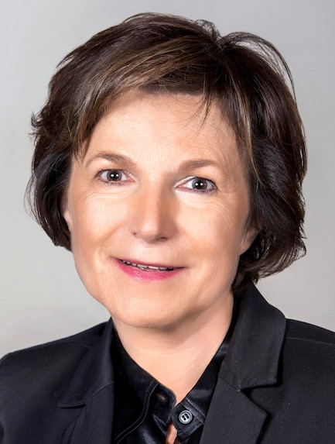
Laurence Boisson de Chazournes
International Arbitrator
University of Geneva, Faculty of Law, 40, boulevard du Pont d'Arve, 1211 Geneva 4 (Switzerland)
+41 (0)22 379 85 44 - laurence.boissondechazournes@unige.ch

Nationality: French/Swiss

Languages: French (native), English (fluent), Spanish (working knowledge)
Member, Matrix Chambers, London (2016-present)

Laurence Boisson de Chazournes has extensive practical experience in the field of international dispute settlement:
- acted as presiding arbitrator, sole arbitrator or wing arbitrator in investment and commercial arbitration proceedings, in pre-shipment inspection cases at the WTO and in other forms of arbitration (such as sports arbitration).
- served as counsel and advocate before the International Court of Justice (ICJ), the International Tribunal for the Law of the Sea (ITLOS) and other international tribunals.
- areas of specialization include, inter alia, energy and environmental issues, natural resources management, trade, mining, tax, maritime and sport issues, investment and public international law.

Experience as arbitrator

- 15+years of experience as Arbitrator in investment, commercial and ad-hoc arbitration proceedings (ICSID, PCA, ICC, UNCITRAL, SCC)
- Presiding Arbitrator in pre-shipment inspection cases at the WTO
- President, sole arbitrator, and co-arbitrator at the Court of Arbitration for Sport (CAS)

Other Professional Experience

- Advocate and Counsel before the International Court of Justice (ICJ) and the International Tribunal for the Law of the Sea (ITLOS)
- Judge, Administrative Tribunal of the Bank for International Settlements (BIS) (2022-)
- Expert with various international organisations (UN, World Bank, WHO, ILO, UNESCO), States, companies, associations and foundations
- President, Center for International Dispute Settlement (CIDS) (2024-); Director of the LL.M. in International Dispute Settlement (MIDS), a joint program of the University of Geneva Faculty of Law and the Graduate Institute of International and Development Studies (2018-2024)
- Visiting Professor in various universities; Professor em, Faculty of Law, University of Geneva, Switzerland; Distinguished Senior Fellow, Graduate Institute of International Studies and Development
- Chaire Avenir commun durable, Collège de France, 2022-2023, "Water resources and international law".
- Senior Counsel, The World Bank, United States (1995-1999).
- Chargée de cours, The Graduate Institute of International Studies (Geneva, Switzerland), and the Faculty of Law of the University of Geneva (Switzerland) (1992-1995).

Nominations and Professional Associations

Member of the list of Arbitrators of the International Center for Settlement of Investment Disputes (ICSID) (2021-present)
Member of the general list of Arbitrators of the Court of Arbitration for Sport (CAS)
Member of the list of Arbitrators of the Swiss ICC Commission of Arbitration and ADR; of the list of Arbitrators of the ICC French National Committee; of the ICC Institute of World Business Law; of the panel of arbitrators of the Hong Kong International Arbitration Centre; of the list of International Arbitrators of the Arbitration Center at the Institute of Modern Arbitration, Moscow; of the list of International Arbitrators of the Center for Arbitration and Conciliation of the Bogotá Chamber of Commerce; of the list of the Panel of Arbitrators of Shenzhen Court of International Arbitration (SCIA Panel of Arbitrators).
Member of the WTO indicative list of governmental and non-governmental panellists; of the list of Arbitrators of the World Intellectual Property Organization (WIPO); of the list of Arbitrators under Annex VII of the United Nations Convention on the Law of the Sea (UNCLOS).
Member of the Panel of Experts for the Trade and Sustainable Development Chapter of the EU-Korea Free Trade Agreement (2012-present); of the list of Arbitrators under the Economic Partnership Agreement between the EU and its Member States and the Southern African Development Community Economic Partnership Agreement (SADC EPA) States (2018-present); of the list of experts for the Trade and Environment chapter (chapter 24) of the EU-Canada Comprehensive Economic and Trade Agreement (CETA) (2018-present); of the list of experts for the Trade and Sustainable Development chapter (chapter 16) of the Economic Partnership Agreement between the EU and Japan (2019-present); of the List of Arbitrators and TSD Experts of the European Union (2022-present); of the EU-UK Trade and Cooperation Agreement (TCA) (2022-present).
Member and Vice-President of the Advisory Committee of the United Nations Human Rights Council (2011-2017)
Member of the Permanent Court of Arbitration (2007-2018)
Member of the list of IDLO arbitrators for IDLO Staff Complaints (2010-2013)
Deputy Chair, Joint Advisory Board, OECD (2009-1918).

Scientific Associations and Distinctions

Louis B. Sohn Award for Public International Law, American Bar Association International Law Section (2025).
Chevalier de la Légion d’honneur, by decree of the President of the French Republic (2024).
Lifetime Achievement Award, Graduate Institute of International Studies and Development (September 2023).
Member, Institute of International Law (2015-present).
Chevalier de l’Ordre National du Mérite, by decree of the President of the French Republic (2015).
Co-Chair, International Council for Commercial Arbitration (ICCA) and American Society of International Law (ASIL), Joint Task Force on Issue Conflicts in Investor-State Arbitration (2013-2016).
Co-Chair, ILA Study Group on the Practice and Procedure of International Tribunals (2008-2010).

Education

Visiting Scholar, University of Michigan Law School (September-December 1990) and Georgetown University Law School (July-October 1994).
Habilitation (post-doctoral exam and certification to teach graduate studies), Université Panthéon-Assas (Paris II), Paris, France, (1991).
Ph.D. in International Law, summa cum laude, Graduate Institute of International Studies, Geneva, Switzerland, March 1991.
Bar Exam, Lyon, France, October 1980; Master in Private Law, magna cum laude, University of Lyon III, France, June 1980; Licence in Sociology, University of Lyon II, France, June 1980; Licence in Law, University of Lyon III, France, June 1979; Diploma in Political Science, magna cum laude, University of Lyon II, France, June 1979.

Publications

Laurence Boisson de Chazournes has authored eight books and edited twenty-five books. She has written over 280 articles and contributions to collective books.

